Set a Tag to Track ecommerce for Facility Reserve

This document used to give a guide to set an independent tag to tracking ecommerce for Facility Reserve which not uses the shopping cart workflow.

Complete one facility reserve transaction, the final page is not the same. We need create different triggers to track these transactions.

# Trigger setting:

The trigger type must be “**DOM Ready**”.

1. The final page url contain “processonlinequickreservation.sdi”. The key words are all lower case.

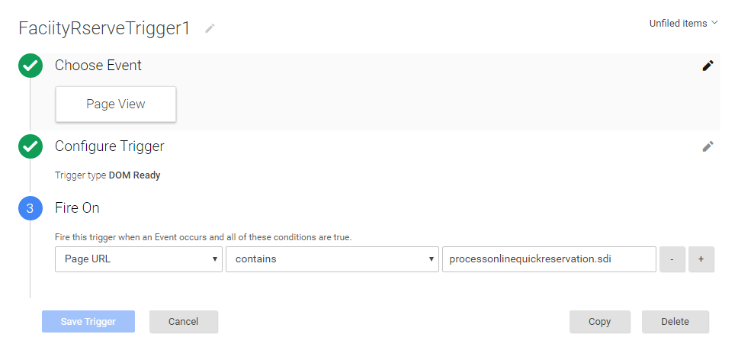

1. The final page url contain “makeOnlineQuickReservation.sdi”

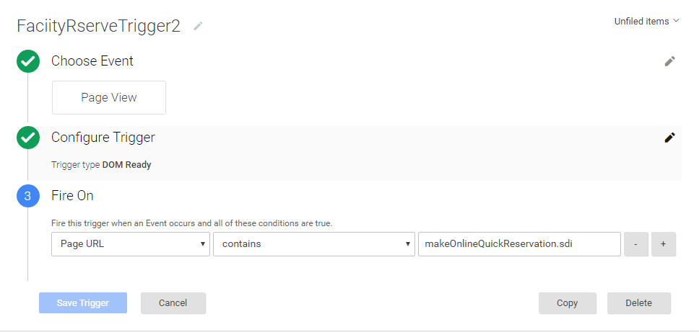

1. The final page url contain “FacilityReceipt.sdi”

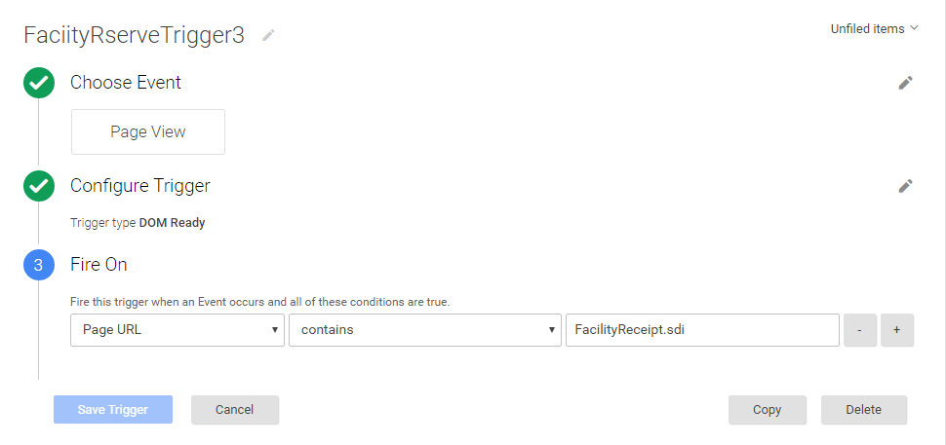

1. The final page url contain “facilityReceipt.sdi”

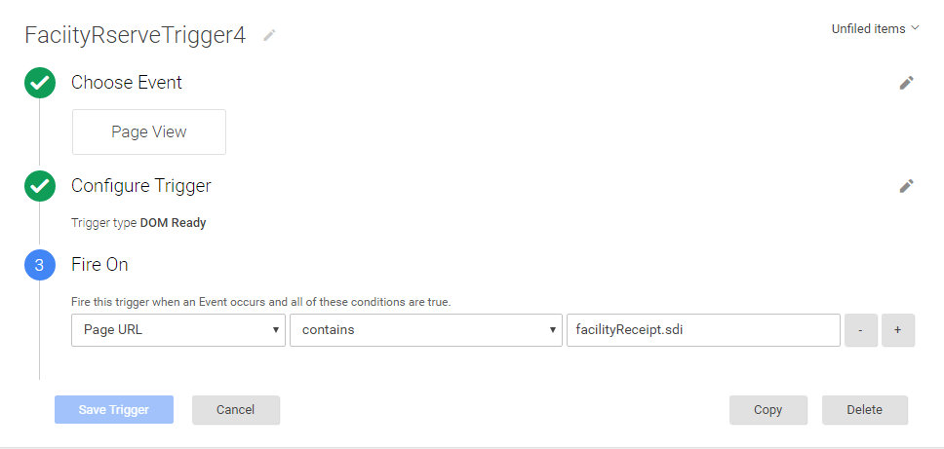

# Tag setting:

Create a tag; make sure the track type is “**Transaction”**. Add the above trigger to fire this tag.

